ABSTRACT
The increased demand of accessible and smart security systems has brought about the flaws of the traditional, costly alarm systems. The proposed project entails the development and execution of a low-cost but highly efficient security system, called a Smart IoT Theft Detector with Alarm and Servo Lock, developed on the environmental platform of the NodeMCU (ESP8266) microcontroller. The system combines Passive Infrared (PIR) sensor that is able to detect motion, a servo motor that doubles as physical lock and the audible/visual notifications (buzzer and LED). The innovation here would be the fact that it is connected to the Blynk IoT system through which a user can remotely arm or disarm the system, get notified immediately when some intrusion occurs, and unlocks the servo-controlled mechanism when entering a correct password, all using a smartphone app. This report explains the entire project life cycle, including the pre balance concept and literature root to actually assembling the hardware, circuit design, writing software and implementation. The outcome is a strong, enterprise, and affordable security system that shows the strength of the Internet of Things (IoT) in the current smart home scenarios.
INTRODUCTION
1.1 PROBLEM STATEMENT
Security has been a paramount concern to homeowners as well as small businesses in present-day society. The conventional type of security system is usually very expensive, in the sense that it consists of equipment that is only very costly, installing the equipment, and also paying the required monthly fees. In addition, the systems are not flexible and can be accessed remotely as desired by modern users. A user that forgets to arm his system after leaving has no option and is usually alerted with a mere alert that they need an enrollment with a monitoring service to get the alert. It is critically evident that there is a need in an inexpensive and easily installable security solution that is also intelligent - it needs to have remote control capabilities and instantaneous notification to the user.
1.2 PROPOSED SOLUTION
The proposed project is an innovative, low cost, and versatile alternative to conventional security systems and designs a Smart IoT Theft Detector. This system is capable of offering strong security at a tenth of that price by exploiting the strength of the Internet of Things (IoT). This system is designed with a NodeMCU (ESP8266), which is a low-priced microcontroller equipped with some Wi-Fi, thus it is procedurally suitable to IoT applications. The system has a Passive Infrared (PIR) sensor that identifies unwarranted movement. When fired, it switches on a local alarm comprising of high-decibel active buzzer and blinking LED. At the same time, it also delivers an immediate push notification to the smartphone of the user through the Blynk IoT platform. With the Blynk application, the user is able to control the arming or disarming of the system remotely anywhere across the globe. The system is also an advanced one as it is controlled by a servo motor as a physical lock. The lock could be unlocked using a password that was typed into the application and provided the necessary entry and access to avoid the alarm.
1.3 OBJECTIVES
The overall aims of this project are the following:
- Low Cost: To have a complete security system implemented with the help of available and cheap electronic parts.
- Motion Detection: To rely on the detection of motion in a secured area, with the help of a PIR sensor.
- Remote Control: The main purpose of this component is to allow the user to arm and disarm the security system remotely in a smartphone app (Blynk).
- Instant Alerts: Instant Alerts To notify the user of his smartphone right away, once an intrusion has been detected.
- Local Alarm: To offer a quick deterrent to intruder by loud, audible alarm (buzzer) and visual alarm (LED).
- Smart Access: To configure a password-protected access control system through the app that operates a physical servo lock and forgoes the alarm in case of authorized persons.
- Scalability: To develop a modular structure that can be easily built up with more sensors (e.g. door/window sensors, smoke detectors).
LITERATURE SURVEY
Home and commercial security is a sphere that has been changing dramatically throughout the last few decades. The current survey investigates available solutions in order to put the innovative and useful nature of the proposed system based on IoT in perspective.
Traditional Alarm Systems: Conventional security systems including offerings by companies such as ADT generally consist of proprietary hardware, professional installation and a cabled connection to a central station of monitoring. Although they are effective, they are expensive at start up with cost and charges that are paid monthly and are thus not reachable by many. Moreover, they are frequently dumb systems, which give minimal user interaction remotely other than a mere keypad.
GSM-Based Alarm Systems: An older version of the smart alarms was the utilization of a GSM (Global System for Mobile Communications) module, a microcontroller (such as an Arduino Uno), and sensors. In cases where an intrusion was detected, an SMS (text message) would be sent to the phone of the owner. This, although being able to give remote notification, had multiple disadvantages: it required a SIM card and SMS plan, the text message was also not as fast as the push notification, and it was a one-way system of communication (arming and disarming the system remotely was difficult because of the SMS).
Raspberry Pi-Based Systems: A more sophisticated approach to DIY solutions will use a Raspberry Pi, which is a high-powered single-board computer. They are capable of current full-fledged operating systems, driving video content of cameras, and contain its web server to operate. This method would be considerably more expensive and complicated, though very powerful and flexible. The cost of Raspberry Pi and SD card and power supply is several folds that of a NodeMCU. It is also Linux and web development based, so it cannot be afforded by many hobbyists.
IoT Platform-Based Systems (Blynk, Cayenne): IoT platforms such as Blynk have changed the scope of diy smart home. These applications offer an existing infrastructure (server, app, and library) to take care of the complicated network communication between the microcontroller and the smartphone. This enables developers to only have to look at the hardware and application logic. System with ESP8266 (such as NodeMCU) and Blynk have a perfect balance. The hardware is extremely affordable, the Wi-Fi is built-in, and the Blynk is a professional-level app interface and free push notifications (on the old platform).
This project is based on the latter solution, which is a synthesis of the low-cost of the NodeMCU and the friendliness and versatility of the Blynk application. It expands the original concept of PIr-to-notification by introducing a state control system (Armed/Disarmed), a physical access control system (the servo lock) and makes it a more complete and realistic approach to security. The proposed system methodology proposed.
METHODOLOGY OF THE PROPOSED SYSTEM
3.1 PRINCIPLE OF OPERATION
The system is run on a fundamental principle of state based logic that is run through the cloud. The NodeMCU microcontroller is the main brain which is always connected to the Blynk IoT server through the local Wi-Fi network.
Two important elements of Boolean variables define the logic of the system:
- systemArmed (bool): This variable gives the state of the alarm. It is operated by a button ( Virtual Pin V1) in the Blynk app. An active system that answers to motion is indicated when the parameter is true. When untrue, it is de-armed, and every movement neglected.
- accessGranted (bool): This is a bypass that is a temporary measure. The app has a password input (Virtual Pin V3) that controls it. Once the right password is given, the accessGranted will be guaranteed to be true, the servo lock will open, and the alarm will also not be able to go off although motion has been detected.
The top loop implements two functions namely Blynk.run() and router.run. The timer.runs, is used to call the checkMotion Ideal whenever one second passes.
The checkMotion() logic is as follows:
- IF systemArmed is true:
- Read the PIR_PIN (D5).
- IF the PIR signal is HIGH (motion detected):
- IF accessGranted is false (i.e., an intruder):
- 1. Trigger the Buzzer (D6).
- 2. Trigger the LED (D7).
- 3. Send a push notification via Blynk.logEvent().
- ELSE (if accessGranted is true):
- - Do nothing. The alarm is bypassed.
- ELSE (if systemArmed is false):
- Do nothing. The system is disarmed.
The approach guarantees that the system is responsive and flexible and avails a safe mechanism through which access could be controlled without raising false alarms.
3.2 BLOCK DIAGRAM
The block diagram below illustrates the flow of information and control within the system. The NodeMCU is the central processing unit, managing inputs from both the physical sensor (PIR) and the cloud (Blynk App). It processes this information based on the system's state and controls all outputs (Alarms, Servo, and App Feedback).
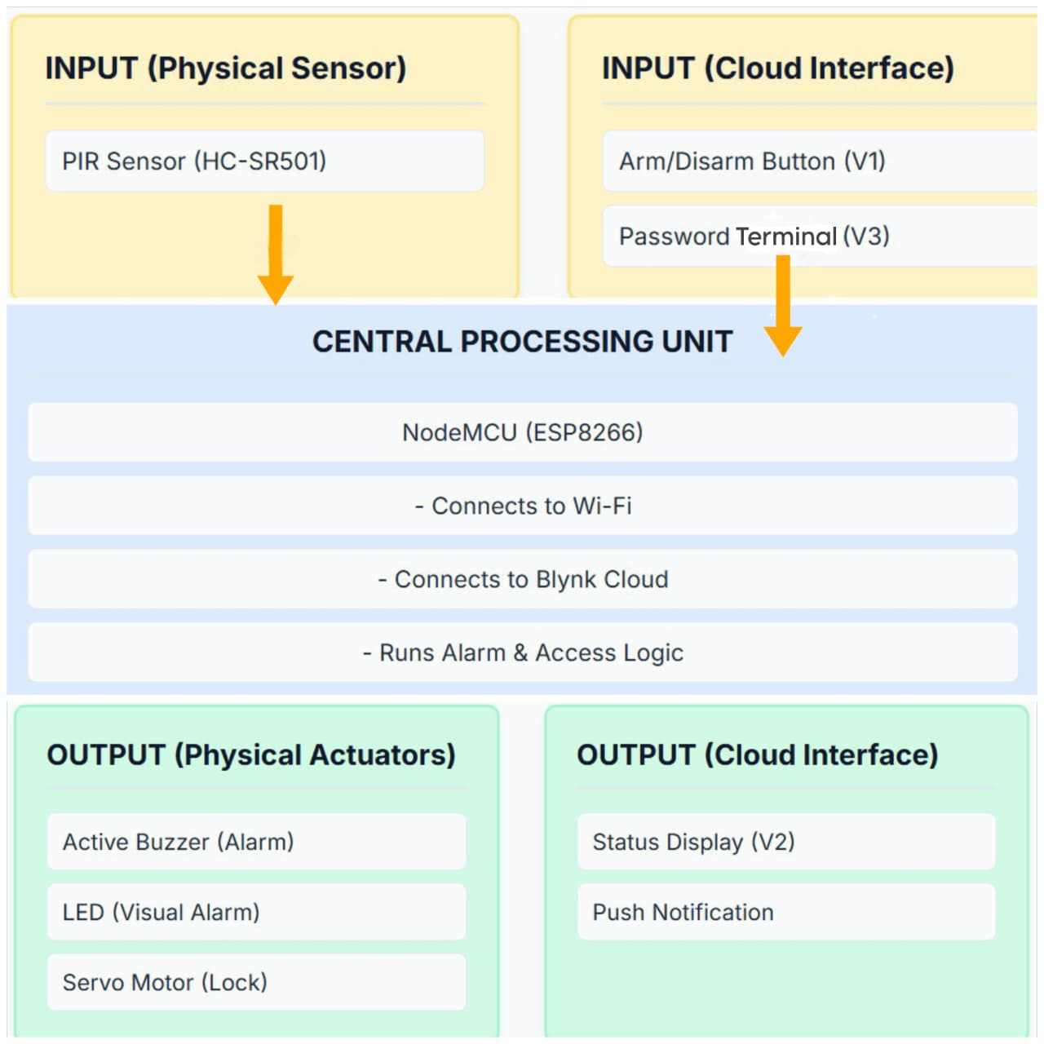
Figure 3.1: Block Diagram of the Smart IoT Theft Detector
3.3 CIRCUIT DIAGRAM AND EXPLANATION
The circuit is designed for simplicity and low power consumption. All components are connected to a central breadboard for power distribution and signal routing to the NodeMCU.
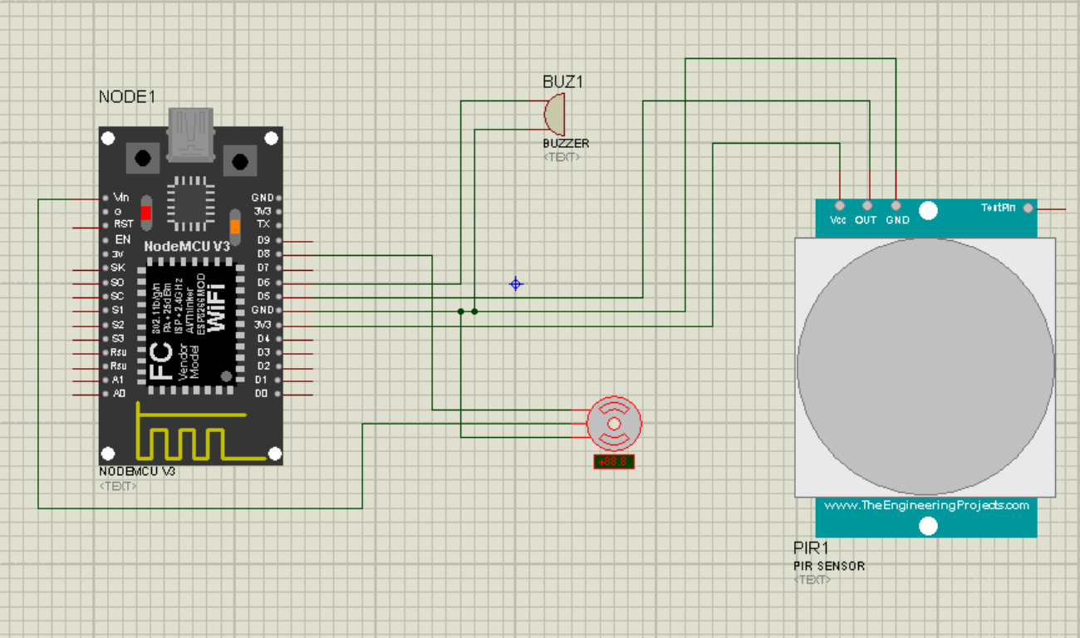
Figure 3.2: Circuit Diagram
Pin Connections:
- Power (5V): The NodeMCU's Vin pin is connected to the breadboard's positive (red) rail. This rail supplies 5V power to the PIR sensor and the Servo Motor.
- Ground (GND): The NodeMCU's GND pin is connected to the breadboard's negative (blue) rail. This rail provides a common ground for all components (PIR, LED, Buzzer, and Servo).
- PIR Sensor (HC-SR501): VCC pin -> Breadboard Positive Rail (5V)
- GND pin -> Breadboard Negative Rail (GND)
- OUT pin -> NodeMCU Pin D5 (This is the signal pin that goes HIGH on motion)
- Active Buzzer: Positive (+) pin -> NodeMCU Pin D6
- Negative (-) pin -> Breadboard Negative Rail (GND)
- LED (Light Emitting Diode): Long Leg (Anode, +) -> 220Ω Resistor -> NodeMCU Pin D7
- Short Leg (Cathode, -) -> Breadboard Negative Rail (GND)
- Servo Motor (SG90): Red Wire (Power) -> Breadboard Positive Rail (5V)
- Brown/Black Wire (Ground) -> Breadboard Negative Rail (GND)
- Orange/Yellow Wire (Signal) -> NodeMCU Pin D8
HARDWARE AND SOFTWARE REQUIREMENTS
4.1 HARDWARE REQUIREMENTS
The following hardware components are used in this project:
- NodeMCU (ESP8266): This is the microcontroller at the heart of the project. It is an open-source, low-cost IoT platform. Its key feature is the integrated ESP8266 Wi-Fi chip, which allows it to connect to the internet and communicate with the Blynk server. It has sufficient GPIO pins to control all the sensors and actuators in this project.
- PIR Sensor (HC-SR501): A Passive Infrared (PIR) sensor measures infrared light radiating from objects in its field of view. It is designed to detect the heat energy given off by humans (or animals), making it an excellent and low-cost motion detector. It outputs a 3.3V digital HIGH signal when motion is detected.
- Servo Motor (SG90): A small, lightweight servo motor used to provide a physical locking mechanism. It can rotate 90-180 degrees. In this project, it is moved to 0 degrees ("locked") and 90 degrees ("unlocked") based on commands from the app.
- Active Buzzer: An active buzzer generates a loud, single-tone sound when a DC voltage is applied. It has an internal oscillator, so it does not require a PWM signal from the microcontroller, simplifying the code. It is used as the audible alarm.
- 5mm LED: A standard Light Emitting Diode used as a visual indicator for the alarm.
- 220Ω Resistor: A current-limiting resistor used to protect the LED from drawing too much current from the NodeMCU's GPIO pin.
- Breadboard and Jumper Wires: Used for prototyping the circuit without soldering, allowing for easy connection and testing of all components.
4.2 SOFTWARE REQUIREMENTS
The following software platforms and libraries are required:
- Arduino IDE (Integrated Development Environment): This is the open-source software used to write, compile, and upload the C++ based code to the NodeMCU board. The ESP8266 board manager must be added to the IDE to provide support for the NodeMCU.
- Blynk (Legacy) App & Platform: Blynk is an IoT platform that simplifies communication between a microcontroller and a smartphone. The (now Legacy) version provides a simple drag-and-drop interface to build a control dashboard on a smartphone. It provides the widgets (buttons, terminal), server connection, and push notification functionality for free. An Auth Token from the app is required to link the hardware to the app.
- Arduino Libraries: ESP8266WiFi.h: This library is part of the ESP8266 core and provides the functions needed to connect the NodeMCU to a Wi-Fi network.
- BlynkSimpleEsp8266.h: This is the official Blynk library that handles all communication, authentication, and virtual pin management between the ESP8266 and the Blynk server.
- Servo.h: This library (the ESP8266-compatible version) provides simple functions to control the servo motor, such as attach() and write().
SYSTEM IMPLEMENTATION AND WORKING
5.1 HARDWARE ASSEMBLY
The implementation began with assembling the hardware on a breadboard as per the circuit diagram in Chapter 3.3.
- The NodeMCU was placed at one end of the breadboard, straddling the central divide.
- The Vin and GND pins from the NodeMCU were connected to the main positive and negative power rails of the breadboard, respectively. This created a "common ground" and a 5V power rail for the components that require it.
- The PIR sensor's VCC and GND pins were connected to the 5V and GND rails. Its OUT pin was connected to D5.
- The SG90 Servo's Red (VCC) and Brown (GND) wires were connected to the 5V and GND rails. Its Orange (Signal) wire was connected to D8.
- The Active Buzzer's + pin was connected to D6, and its - pin to the GND rail.
- The LED's short leg (cathode) was connected to the GND rail. Its long leg (anode) was connected to one end of the 220Ω resistor, with the other end of the resistor connected to D7.
This configuration ensures all components are properly powered and share a common ground, which is essential for correct digital signal interpretation.
5.2 BLYNK DASHBOARD SETUP
A crucial part of the implementation is setting up the mobile application interface. This was done using the Blynk (Legacy) app.
- A new project was created in the Blynk app. The device was set to "NodeMCU" and connection type to "Wi-Fi".
- The app generated an Auth Token, which was copied and pasted into the BLYNK_AUTH_TOKEN definition in the Arduino code.
- The following widgets were added to the dashboard:
- Button (V1): Set to "Switch" mode. This toggles the systemArmed variable. Labels were set to "Armed" (for ON) and "Disarmed" (for OFF).
- Labeled Value (V2): This widget is used for status display. The code (Blynk.virtualWrite(V2, ...)) sends strings like "Armed", "Password Accepted", etc., to this widget.
- Terminal (V3): This widget provides a command-line-like input. The user types the password ("1234") and presses send. The code reads this string from BLYNK_WRITE(V3).
- Notification Widget: This widget requires no setup; adding it to the dashboard simply enables the Blynk.logEvent() function in the code to send push notifications.
  - CODE
/*
* NodeMCU Security System with Blynk
* Features: PIR Motion Detection, Password Authentication, Email/Notification Alerts
*
* Blynk Virtual Pins:
* V0 - Password Input (String)
* V1 - System Mode Switch (1=Armed, 0=Unarmed)
* V2 - Virtual LED (Motion Detection Indicator)
*/
#define BLYNK_TEMPLATE_ID "TMPL3U7PkKwmn"
#define BLYNK_TEMPLATE_NAME "Security"
#define BLYNK_AUTH_TOKEN "ExGiDII6hYtrH0xRJjpPJr3elciR41LH"

#define BLYNK_PRINT Serial
#include <ESP8266WiFi.h>
#include <BlynkSimpleEsp8266.h>
#include <Servo.h>

// WiFi Credentials
char ssid[] = "jk";
char pass[] = "hello meetu";

// Pin Definitions (NodeMCU)
#define PIR_PIN D5 // PIR Sensor
#define LED_PIN D6 // Physical LED
#define BUZZER_PIN D7 // Buzzer
#define SERVO_PIN D2 // Servo Motor

// Blynk Virtual Pins
#define VPIN_PASSWORD_IN V0 // Password input
#define VPIN_MODE_SWITCH V1 // Armed/Unarmed switch
#define VPIN_VLED V2 // Virtual LED

// System Variables
Servo doorServo;
bool isArmed = true; // System mode: true = Armed, false = Unarmed
bool motionDetected = false;
bool doorOpen = false;
bool waitingForPassword = false;
String correctPassword = "1234"; // Set your password here
String enteredPassword = "";
unsigned long motionTime = 0;
unsigned long buzzerStartTime = 0;
bool buzzerActive = false;

BlynkTimer timer;
WidgetLED motionLED(VPIN_VLED);

void setup() {
Serial.begin(115200);

// Pin Modes
pinMode(PIR_PIN, INPUT);
pinMode(LED_PIN, OUTPUT);
pinMode(BUZZER_PIN, OUTPUT);

// Initial States
digitalWrite(LED_PIN, LOW);
digitalWrite(BUZZER_PIN, LOW);

// Servo Setup
doorServo.attach(SERVO_PIN);
doorServo.write(0); // Door closed position (0 degrees)

// Connect to Blynk
Serial.println("Connecting to WiFi...");
Blynk.begin(BLYNK_AUTH_TOKEN, ssid, pass);

// Setup Timer
timer.setInterval(200L, checkMotion); // Check motion every 200ms

Serial.println("Security System Started!");
Serial.println("System Mode: ARMED");

// Initialize Blynk widgets
Blynk.virtualWrite(VPIN_MODE_SWITCH, 1); // Set to ARMED
motionLED.off();
}

void loop() {
Blynk.run();
timer.run();

// Handle buzzer timeout (ring for 10 seconds)
if (buzzerActive && (millis() - buzzerStartTime > 10000)) {
digitalWrite(BUZZER_PIN, LOW);
buzzerActive = false;
Serial.println("Buzzer stopped");
}

// Auto-reset after 20 seconds if waiting for password
if (waitingForPassword && (millis() - motionTime > 20000)) {
Serial.println("Password timeout - System reset");
resetSystem();
}
}

// Check PIR Sensor
void checkMotion() {
int pirState = digitalRead(PIR_PIN);

if (pirState == HIGH && !motionDetected) {
motionDetected = true;
motionTime = millis();

// Turn on LEDs (always happens)
digitalWrite(LED_PIN, HIGH);
motionLED.on(); // Turn on Blynk Virtual LED

Serial.println("━━━━━━━━━━━━━━━━━━━━━━━━━━");
Serial.println("🚨 MOTION DETECTED!");
Serial.println("━━━━━━━━━━━━━━━━━━━━━━━━━━");

if (isArmed) {
// ARMED MODE: Wait for password
waitingForPassword = true;
Serial.println("🔒 System ARMED");
Serial.println("⏳ Waiting for password...");
Serial.println("⚠ Enter password within 20 seconds!");

// Send notification to Blynk
Blynk.logEvent("motion_detected", "Motion detected! Enter password.");

} else {
// UNARMED MODE: Open door automatically
Serial.println("🔓 System UNARMED");
Serial.println("✅ Opening door automatically...");
openDoor();
}
}
}

// Blynk: System Mode Switch (V1)
BLYNK_WRITE(V1) {
int switchValue = param.asInt();

if (switchValue == 1) {
isArmed = true;
Serial.println("\n━━━━━━━━━━━━━━━━━━━━━━━━━━");
Serial.println("🔒 System Mode: ARMED");
Serial.println("━━━━━━━━━━━━━━━━━━━━━━━━━━\n");
Blynk.logEvent("system_mode", "Security system is now ARMED");
} else {
isArmed = false;
Serial.println("\n━━━━━━━━━━━━━━━━━━━━━━━━━━");
Serial.println("🔓 System Mode: UNARMED");
Serial.println("━━━━━━━━━━━━━━━━━━━━━━━━━━\n");
Blynk.logEvent("system_mode", "Security system is now UNARMED");
}

resetSystem(); // Reset when mode changes
}

// Blynk: Password Input (V0)
BLYNK_WRITE(V0) {
enteredPassword = param.asStr();

if (motionDetected && isArmed && waitingForPassword) {
Serial.print("🔑 Password entered: ");
Serial.println(enteredPassword);

if (enteredPassword == correctPassword) {
// Correct Password
Serial.println("✅ Password CORRECT!");
Serial.println("🚪 Opening door...\n");
Blynk.logEvent("access_granted", "Correct password. Access granted.");
openDoor();

} else {
// Wrong Password - INTRUSION!
Serial.println("❌ Password INCORRECT!");
Serial.println("🚨 INTRUSION ALERT!\n");
handleIntrusion();
}
} else if (!waitingForPassword) {
Serial.println("⚠ No motion detected. Trigger PIR sensor first.");
}
}

// Open Door Function
void openDoor() {
doorOpen = true;
waitingForPassword = false;

// Rotate servo to 90 degrees (open position)
doorServo.write(90);
Serial.println("━━━━━━━━━━━━━━━━━━━━━━━━━━");
Serial.println("✅ DOOR OPENED");
Serial.println("━━━━━━━━━━━━━━━━━━━━━━━━━━");

// Keep door open for 5 seconds
delay(5000);

// Close door
doorServo.write(0);
doorOpen = false;
Serial.println("🚪 Door closing...");
Serial.println("━━━━━━━━━━━━━━━━━━━━━━━━━━\n");

resetSystem();
}

// Handle Intrusion (Wrong Password)
void handleIntrusion() {
waitingForPassword = false;

// Activate Buzzer
digitalWrite(BUZZER_PIN, HIGH);
buzzerActive = true;
buzzerStartTime = millis();

Serial.println("━━━━━━━━━━━━━━━━━━━━━━━━━━");
Serial.println("🚨 INTRUSION DETECTED!");
Serial.println("🔊 Buzzer activated");
Serial.println("📧 Sending notifications...");
Serial.println("━━━━━━━━━━━━━━━━━━━━━━━━━━\n");

// Send Notifications
Blynk.logEvent("intrusion_alert", "INTRUSION! Wrong password entered!");

// Don't reset immediately - let buzzer run
}

// Reset System
void resetSystem() {
motionDetected = false;
doorOpen = false;
waitingForPassword = false;
enteredPassword = "";

digitalWrite(LED_PIN, LOW);
digitalWrite(BUZZER_PIN, LOW);
buzzerActive = false;

motionLED.off(); // Turn off Blynk Virtual LED

Serial.println("🔄 System Reset - Ready for next detection\n");
}

// Connected to Blynk
BLYNK_CONNECTED() {
Serial.println("✅ Connected to Blynk!");
Blynk.syncVirtual(VPIN_MODE_SWITCH); // Sync the mode switch state
}

  - SYSTEM WORKFLOW
The complete operational flow of the system is as follows:
1. Power On & Initialization:
- The user connects the NodeMCU to a USB power source.
- The setup() function runs.
- The Serial Monitor begins (at 115200 baud).
- All pins (PIR, Buzzer, LED) are set to their modes.
- The servo is attached to pin D8 and immediately moves to 0 degrees (the "locked" position).
- The system connects to the Wi-Fi network specified in the code.
- The system connects to the Blynk server using the Auth Token.
- The checkMotion() function is set to run every 1000ms (1 second).
- The system's initial state is set to systemArmed = true, and "Armed" is written to the V2 display.
2. Scenario 1: Intrusion Detected (Alarm)
- The system is in its "Armed" state.
- An intruder walks in front of the PIR sensor.
- The PIR sensor's OUT pin goes HIGH.
- The next second, checkMotion() runs. It sees systemArmed == true and pirValue == HIGH.
- It checks accessGranted, which is false.
- The alarm is triggered: digitalWrite(LED_PIN, HIGH), beepBuzzer(2000, false) runs, and Blynk.logEvent("intrusion_alert", ...) sends a push notification to the user's phone.
3. Scenario 2: Authorized User Access
- A user approaches the door. They first open the Blynk app.
- They type the correct password ("1234") into the Terminal (V3) and press Send.
- The BLYNK_WRITE(V3) function is triggered on the NodeMCU.
- The code checks if (entered == correctPassword). This is true.
- accessGranted is set to true.
- "Password Accepted" is written to V2.
- myServo.write(90) runs, moving the lock to the "unlocked" position.
- The user now walks in front of the PIR sensor.
- checkMotion() runs. It sees systemArmed == true and pirValue == HIGH.
- It checks accessGranted, which is now true.
- The if (!accessGranted) block is skipped. No alarm is triggered.
4. Scenario 3: Remote Disarm
- The user wants to turn the system off.
- They press the Button (V1) in the Blynk app.
- The BLYNK_WRITE(V1) function is triggered.
- systemArmed is set to false.
- "Disarmed" is written to V2.
- The servo is moved to 0 degrees (locked) and accessGranted is reset to false as a security precaution.
- Now, any motion detected by the PIR sensor is ignored by checkMotion() because systemArmed is false.
RESULTS AND DISCUSSION
The system was successfully assembled and tested, and it performed according to all design objectives. The results confirmed that the combination of a NodeMCU, sensors, and the Blynk platform creates a responsive and reliable security system.
1. System Boot and Connection:
Upon powering on, the NodeMCU successfully connected to the specified Wi-Fi network within 5-10 seconds. The Serial Monitor output (Figure 7.1) confirmed a successful Wi-Fi connection and subsequent connection to the Blynk server. The servo motor immediately moved to the 0-degree position, and the Blynk app updated the status on V2 to "Armed."
2. Blynk App Interface:
The Blynk dashboard (Figure 7.2) provided a simple and intuitive user interface. The Arm/Disarm button (V1) responded instantly, and the Labeled Value display (V2) correctly reflected the system's current state ("Armed", "Disarmed", "Password Accepted", "Wrong Password").

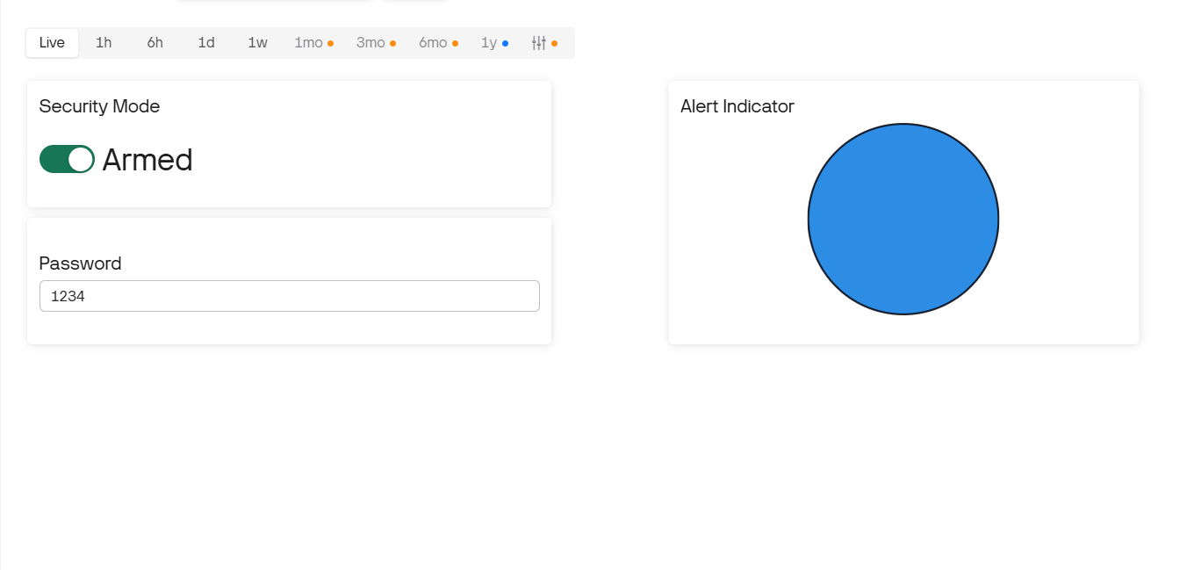
Figure 7.1: Blynk App Dashboard
3. System Functionality:
- Intrusion Test: While the system was "Armed," waving a hand in front of the PIR sensor resulted in an immediate response: the LED and Buzzer activated for 2 seconds, and a push notification (Figure 7.3) was received on the smartphone within 1-2 seconds.
- Password Access Test: Entering "1234" into the V3 terminal correctly set the accessGranted flag, moved the servo to 90 degrees, and updated the status to "Password Accepted." Subsequent motion in front of the PIR sensor did not trigger the alarm.
- Wrong Password Test: Entering "1111" updated the status to "Wrong Password" and did not move the servo, as expected.
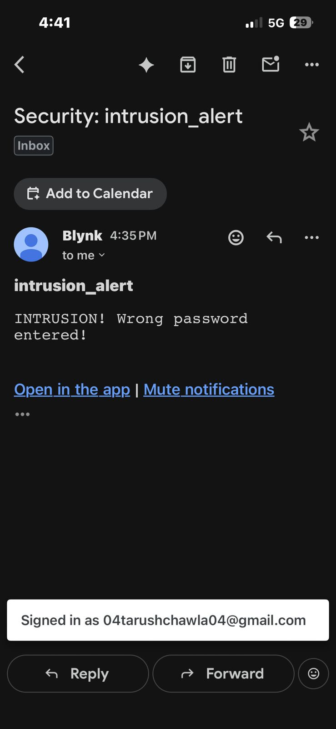
Figure 7.3: Intrusion Alert Notification
Discussion of Challenges:
One minor challenge encountered was a false alarm immediately upon boot-up. This is due to the PIR sensor's "warm-up" period, during which its output pin goes HIGH for several seconds. Since the code starts checking for motion after 1 second, it interprets this as an intrusion. A simple fix would be to add a delay (30000) (30-second delay) in the setup() function to allow the sensor to calibrate before the main loop begins. Another challenge is the high current draw of the servo motor, which can sometimes cause the NodeMCU to reset if powered from a weak USB port. For a permanent installation, a dedicated 5V 2A external power supply would be recommended.
CONCLUSION AND FUTURE SCOPE
8.1 CONCLUSION
This project successfully demonstrates the design, development, and implementation of a Smart IoT Theft Detector. By integrating a NodeMCU ESP8266 with a PIR sensor, a servo motor, and the Blynk IoT platform, we have created a security system that is not only highly functional but also extremely low-cost and accessible. The system meets all its stated objectives: it provides reliable motion detection, instant push notifications, remote arm/disarm capabilities, and a password-protected physical lock.
The project highlights the transformative potential of IoT technology in the home security domain. It proves that a robust, smart, and interactive security system can be built by hobbyists and students, democratizing access to technology that was once reserved for expensive, professionally-installed systems. The final prototype is a practical and effective solution for securing a room, desk, or personal cabinet.
8.2 FUTURE SCOPE
While the current system is fully functional, its modular design allows for numerous potential upgrades and enhancements. Future work on this project could include:
- Additional Sensors: Integrating magnetic reed switches (for doors and windows) or vibration sensors to provide different types of intrusion detection.
- Camera Integration: Upgrading the microcontroller to an ESP32-CAM, which could be programmed to take a photograph of the intruder when the PIR sensor is triggered and email it to the user.
- Blynk 2.0 Migration: Migrating the project from Blynk (Legacy) to the new Blynk 2.0 platform, which offers more advanced features, data logging, and long-term support.
- Battery Backup: Adding a battery pack (e.g., using a LiPo battery with a charging module) to ensure the system remains operational during a power outage.
- Two-Factor Authentication: Implementing a more secure access protocol, such as requiring both the password and an RFID tag scan to disarm the system.
REFERENCES
- Blynk (Legacy) Documentation. (n.d.). Retrieved from https://docs.blynk.io/en/legacy
- NodeMCU ESP8266 Datasheet. (n.d.). Espressif Systems. Retrieved from https://www.espressif.com/en/products/socs/esp8266
- Arduino IDE. (n.d.). Retrieved from https://www.arduino.cc/en/software
- HC-SR501 PIR Sensor Datasheet. (n.d.). Retrieved from https://www.mpja.com/download/31227mp.pdf
- TowerPro SG90 Servo Motor Datasheet. (n.d.). Retrieved from http://www.ee.ic.ac.uk/pcheung/teaching/DE1-1/docs/SG90-datasheet.pdf
- Monk, S. (2016). Programming Arduino: Getting Started with Sketches. McGraw-Hill Education.

